CONTROL SYSTEMS MINI PROJECT

By: Ayushman Singh

Roll no.- 05110102819

Ece-1(Sem-5)

**Servo motor control using potentiometer**

**Aim**-Control the position of servo motor using Arduino and potentiometer.

**Hardware required**- Arduino Board, Servo Motor, 10k ohm Potentiometer, Jumper Wires, Mini Breadboard

**Software used**- Proteus 8, Arduino ide.

**Theory:**

**Servo motors-**A servomotor is a linear actuator or rotary actuator that allows for precise control of linear or angular position, acceleration, and velocity. It consists of a motor coupled to a [sensor](https://www.electrical4u.com/sensor-types-of-sensor/) for position feedback. It also requires a relatively sophisticated controller, often a dedicated module designed specifically for use with servomotors.

**Working of servo motor**

A servo motor is a self-contained electrical device, that rotate parts of a machine with high efficiency and with great precision.

The output shaft of this motor can be moved to a particular angle, position and velocity that a regular motor does not have.

The Servo Motor utilizes a regular motor and couples it with a sensor for positional feedback.

The controller is the most important part of the Servo Motor designed and used specifically for this purpose.

The servo motor is a closed-loop mechanism that incorporates positional feedback in order to control the rotational or linear speed and position.

The motor is controlled with an electric signal, either analog or digital, which determines the amount of movement which represents the final command position for the shaft.

A type of encoder serves as a sensor providing speed and position feedback. This circuitry is built right inside the motor housing which usually is fitted with gear system.

**Servo motor applications**

These are commonly seen in remote-controlled toy cars for controlling the direction of motion, and it is also very widely used as the motor which moves the tray of a CD or DVD player. Besides these, there are hundreds of servo motor applications we see in our daily life.

The main reason behind using a servo is that it provides angular precision, i.e., it will only rotate as much we want and then stop and wait for the next signal to take further action. The servo motor is unlike a standard electric motor which starts turning as when we apply power to it, and the rotation continues until we switch off the power. We cannot control the rotational progress of electrical motor, but we can only control the speed of rotation and can turn it ON and OFF. Small servo motors are included many [beginner Arduino starter kits](https://www.electrical4u.com/best-arduino-starter-kit/), as they are easy to operate as part of a small electronics projects.

**Arduino uno**

The Arduino Uno is a microcontroller board based on the ATmega328. It has 20 digital input/output pins (of which 6 can be used as PWM outputs and 6 can be used as analog inputs), a 16 MHz resonator, a USB connection, a power jack, an in-circuit system programming (ICSP) header, and a reset button. It contains everything needed to support the microcontroller; simply connect it to a computer with a USB cable or power it with a [AC-to-DC adapter](https://www.pololu.com/product/1463) or battery to get started.

The Uno differs from all preceding boards in that it does not use the FTDI USB-to-serial driver chip. Instead, it features an ATmega16U2 programmed as a USB-to-serial converter. This auxiliary microcontroller has its own USB bootloader, which allows advanced users to reprogram it.

**Potentiometer**

Potentiometers also known as **POT**, are nothing but **variable resistors**. They can provide a variable resistance by simply varying the knob on top of its head. It can be classified based on two main parameters. One is their **Resistance (R-ohms)**itself and the other is its **Power (P-Watts)** rating.

The value or resistance decides how much opposition it provides to the flow of current. The greater the resistor value the smaller the current will flow. Some standard values for a potentiometer are 500Ω, 1K, 2K, 5K, 10K, 22K, 47K, 50K, 100K, 220K, 470K, 500K, 1 M.

Resistors are also classified based on how much current it can allow; this is called Power (wattage) rating. The higher the power rating the bigger the resistor gets and it can also more current. For potentiometers the power rating is 0.3W and hence can be used only for low current circuits.

**Applications**

* Voltage and Current Control Circuits
* Used as volume control knobs in radios
* Tuning or controlling circuits
* Analog input control knobs

**Structure of the project**

The structure or the circuit is shown below.

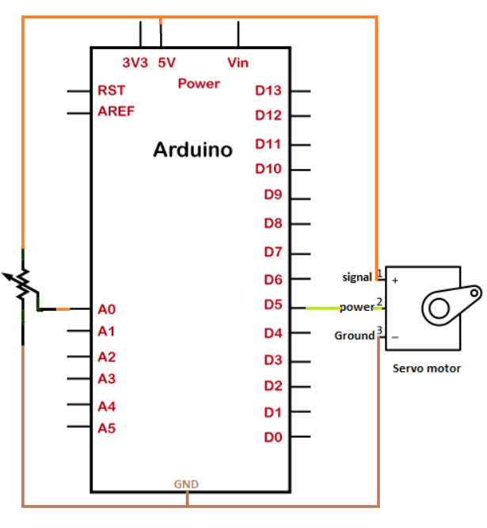

### Connection

The steps to set up the connection are listed below:

* Connect the signal terminal of the servo motor to the 5V pin of the Arduino board.
* Connect the power terminal of the servo motor to pin 9 of the Arduino board. We can connect the power terminal of the motor to any digital PWM pin on the Arduino board.
* Connect the ground terminal of the servo motor to the GND pin of the Arduino board.
* One outer pin of the Potentiometer is connected to the ground (**GND**), and other external pin is connected to **5V** of the Arduino board.
* The middle terminal of the Potentiometer is connected to the analog input pin A0 of the board.

**Arduino code/sketch**

#include <Servo.h>

Servo myservo; // create servo object to control a servo

int potpin = A0; // analog pin used to connect the potentiometer

int val; // variable to read the value from the analog pin

void setup() {

myservo.attach(9); // attaches the servo on pin 9 to the servo object

}

void loop() {

val = analogRead(potpin); // reads the value of the potentiometer (value between 0 and 1023)

val = map(val, 0, 1023, 0, 180); // scale it for use with the servo (value between 0 and 180)

myservo.write(val); // sets the servo position according to the scaled value

delay(15); // waits for the servo to get there

}

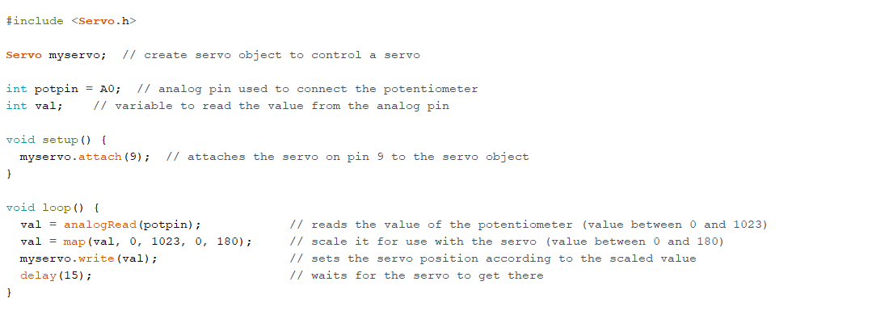

**Simulation**

Here are some pictures of the servo motor at different values given by potentiometer. As a result servo motor stops at different angles.

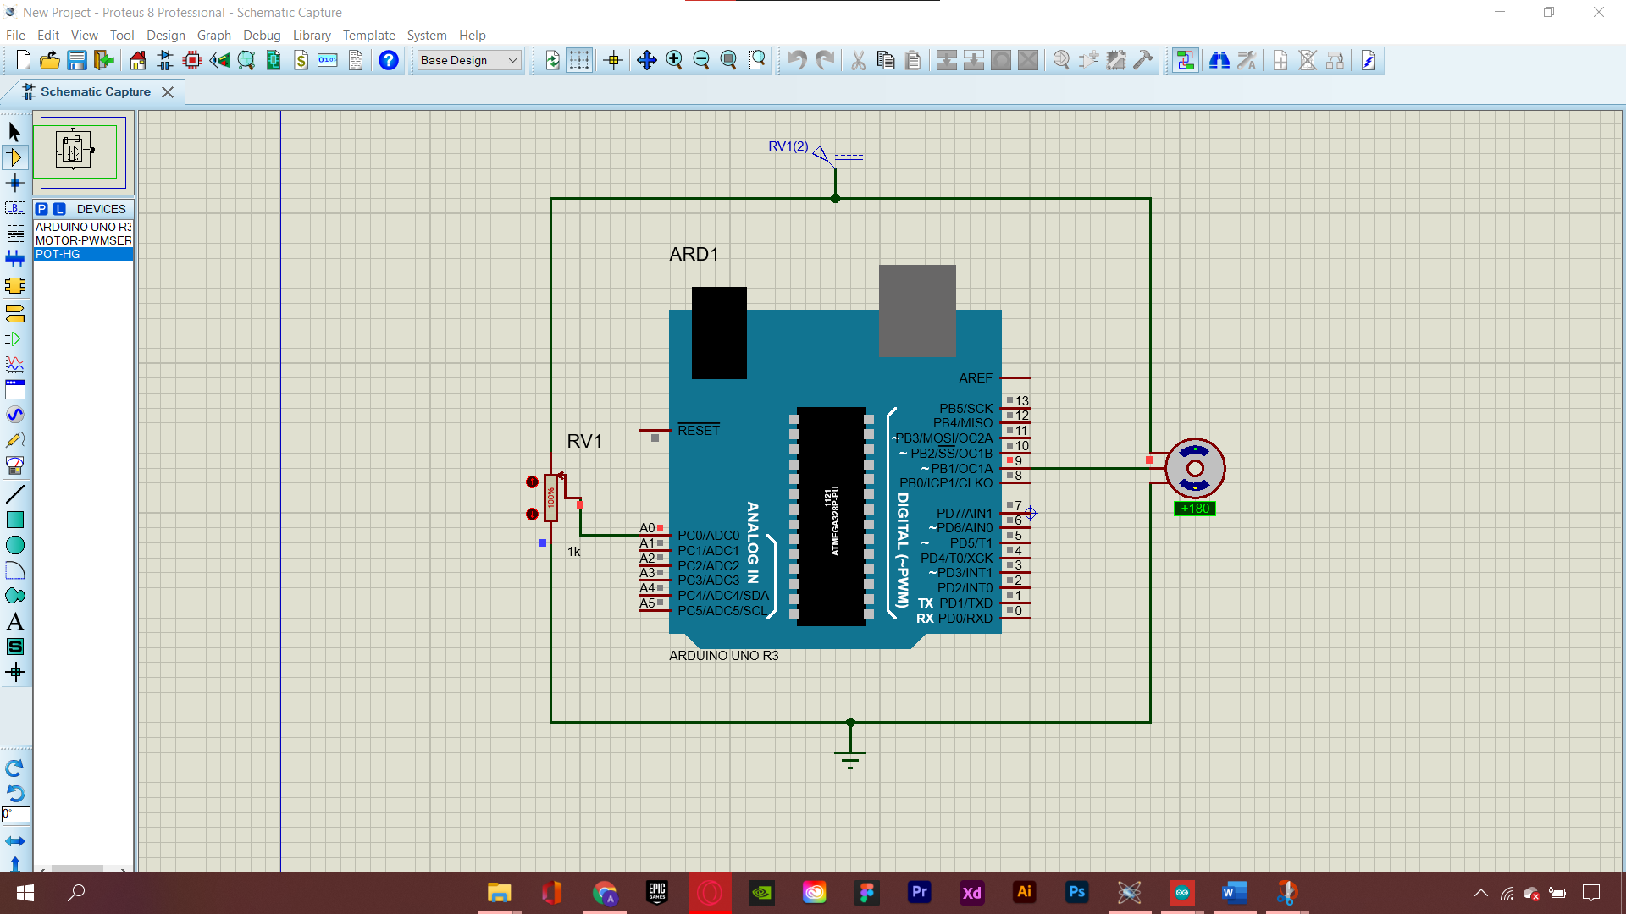

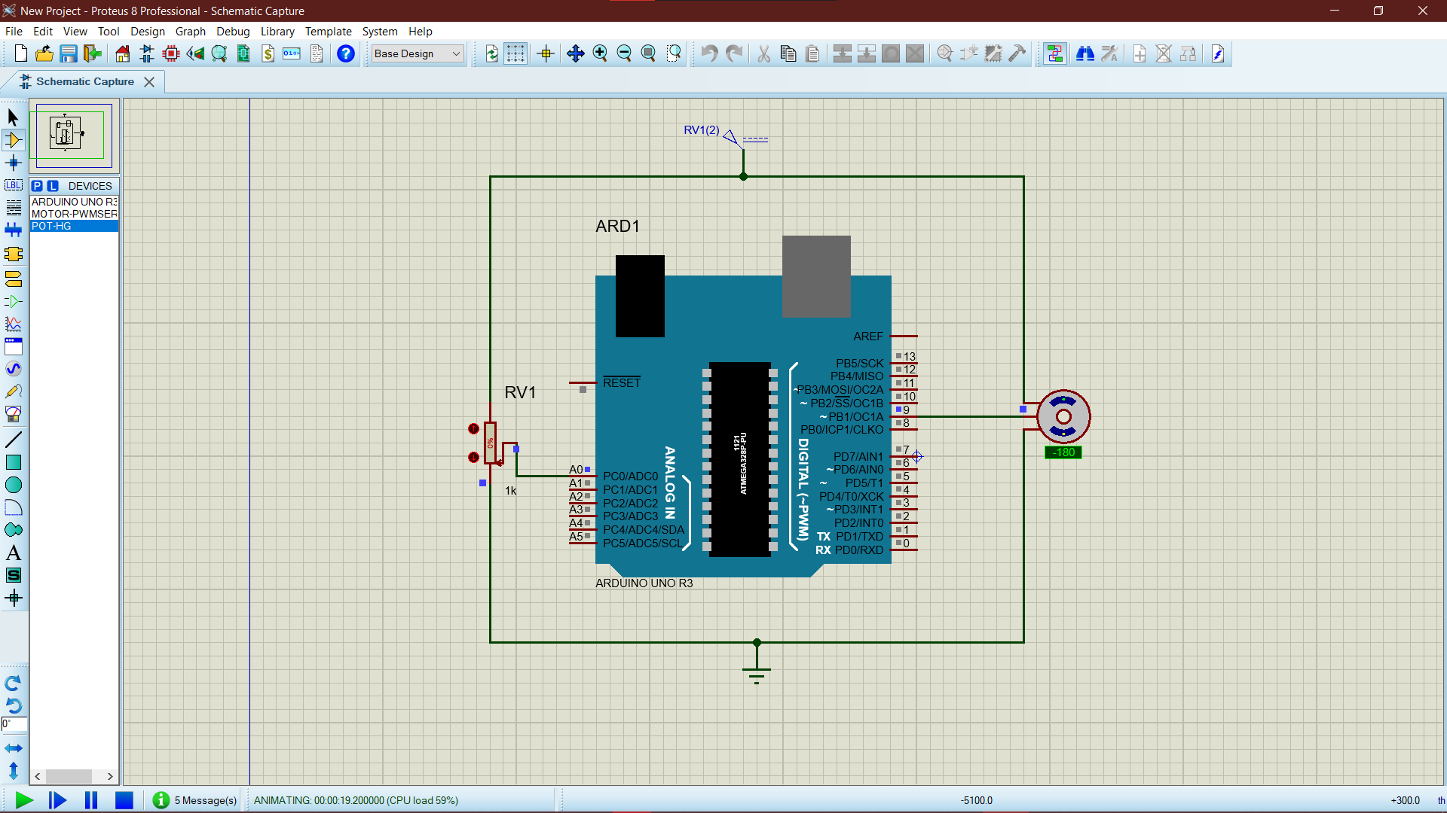

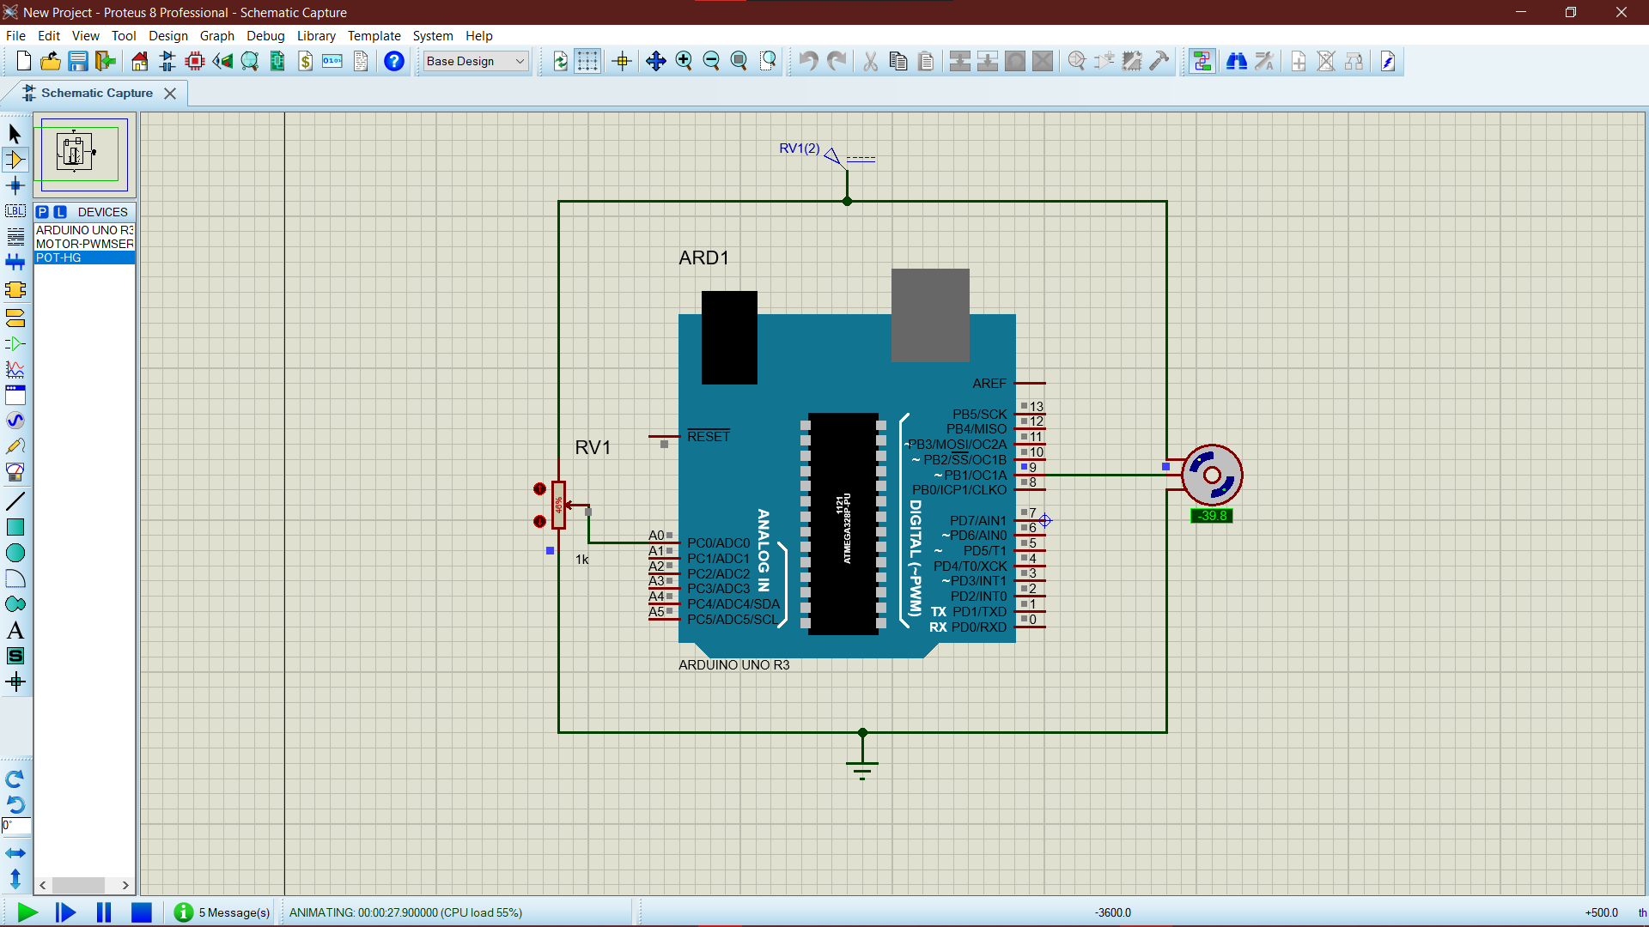

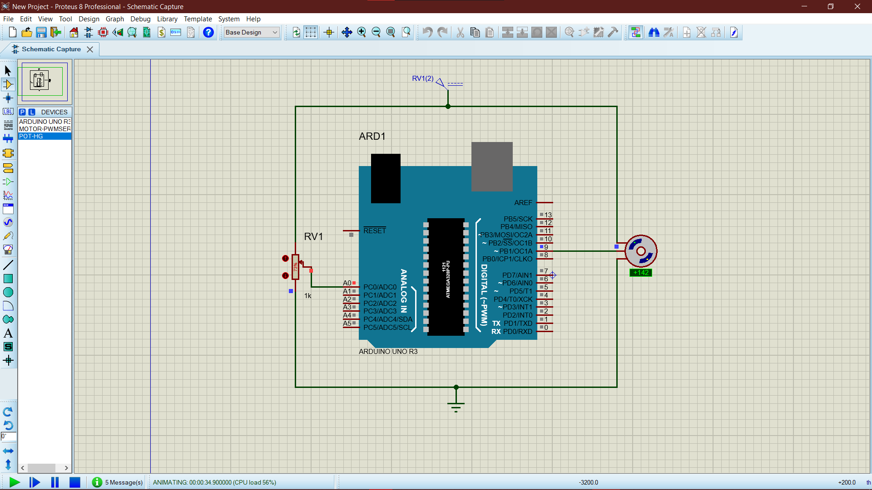

**Output**

The shaft will rotate at angles between 0 and 180 degrees and again in the reverse direction.

We can also modify the code by specifying it only in one direction from 0 to 180 degrees. Hence, we can make changes according to the requirements.